Date: 2014-07-07

PROBLEM SPECIFICATION

Filtering an image using Maximum, Minimum, Median, Weighted Median Filter

INPUT

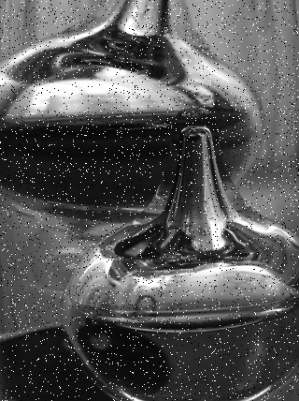

PROCESSING STEP FOR MAX, MEDIAN & MEDIAN FILTER

1. Load an image(I)
2. If image I is an RGB image convert into gray scale image  
   that is I=rgb2gray(I);
3. Get the copy of the Image I as W
4. For each intensity value of image I (starting from 2 to row-1 and like 2 to col-1) do :

Initialize an Matrix M

Move Filter Matrix from as 3x3 Matrix and store the first 3 rows and 3 cols value to M[]

- If it is Maximum Filter find the value of Maximum and assign it to hotspot.

* If it is Maximum Filter find the value of Maximum and assign it to hotspot.

- If it is Maximum Filter find the value of Maximum and assign it to hotspot.

End For

1. Finally plot the Filtered images and its histogram.

PROCESSING STEP FOR WEIGHTED MEDIAN FILTER

1. Load an image(I)
2. If image I is an RGB image convert into gray scale image  
   that is I=rgb2gray(I);
3. Get the copy of the Image I as W
4. For each intensity value of image I (starting from 2 to row-1 and like 2 to col-1) do :

Initialize an Matrix M

Move Filter Matrix from as 3x3 Matrix and store the first 3 rows and 3 cols value to M[]

For each value in Filter Matrix Count the value and store it as vector and find the mean of the vector

Then assign the mean as hotspot.

End For

1. Finally plot the Filtered images and its histogram.

OUTPUT

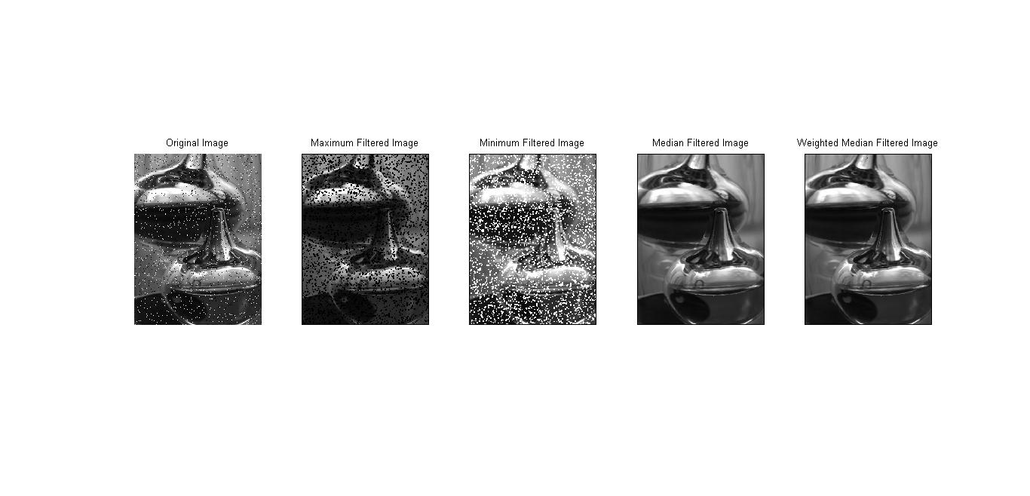

Program Listing

function [M] = MinFilter(I,str)

if length(size(I)) == 3

I=rgb2gray(I);

end

[row,col] = size(I);

M=zeros(row,col);

for x=2:row-1

for y=2:col-1

M2=[];

for i=-1:1

for j=-1:1

a=I(x+i,y+j);

M2=[M2 a];

end

end

if strcmp(str,'Min')

a=min(M2);

end

if strcmp(str,'Max')

a=max(M2);

end

if strcmp(str,'Median')

a=median(M2);

end

M(x,y)=a;

end

end

M=uint8(M);

I=imread('./../images/pap.png');

H=[1 2 1; 2 3 2; 1 2 1];

Min=MinFilter(I,'Min');

Max=MinFilter(I,'Max');

Median=MinFilter(I,'Median');

Weighted=WeightedMedian(I,H);

subplot(1,5,1);imshow(I);title('Original Image');

subplot(1,5,2);imshow(Min);title('Maximum Filtered Image');

subplot(1,5,3);imshow(Max);title('Minimum Filtered Image');

subplot(1,5,4);imshow(Median);title('Median Filtered Image');

subplot(1,5,5);imshow(Weighted);title('Weighted Median Filtered Image');

**%For Weighted Mean**

function [W] = WeightedMedian(I,H)

if length(size(I)) == 3

I=rgb2gray(I);

end

[row,col] = size(I);

W=zeros(row,col);

for x=2:row-1

for y=2:col-1

M2=[];

for i=-1:1

for j=-1:1

a=I(x+i,y+j);

p=H(i+2,j+2);

for k=1:p

M2=[M2 a];

end

end

end

a=median(M2);

W(x,y)=a;

end

end

W=uint8(W);

% Read the image

I=imread('./../images/baboon.jpg');

% Various filter

Gauss=[0 1 2 1 0;1 3 5 3 1;2 5 9 5 2;1 3 5 3 1;0 1 2 1 0];

Box=ones(5,5);

Lap=[0 0 -1 0 0; 0 -1 -2 -1 0; -1 -2 16 -2 -1 ; 0 -1 -2 -1 0; 0 0 -1 0 0];

% Genrate Filtered Image

[G] = GaussFilter(I,Gauss);

[B] = BoxFilter(I,Box);

[L] = Laplacian(I,Lap);

% Generate Hisograms

[h,I] = histogram(I);

[hG,G] = histogram(G);

[hB,B] = histogram(B);

[hL,L] = histogram(L);

% Show the images

subplot(4,2,1);imshow(I);

subplot(4,2,3);imshow(G);

subplot(4,2,5);imshow(B);

subplot(4,2,7);imshow(L);

% Plot Histograms

subplot(4,2,2);plot(h);

subplot(4,2,4);plot(hG);

subplot(4,2,6);plot(hB);

subplot(4,2,8);plot(hL);